Day 8 Functions with inputs

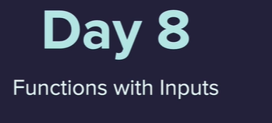

Building a Caesar Cipher

Passing the a variable into a function

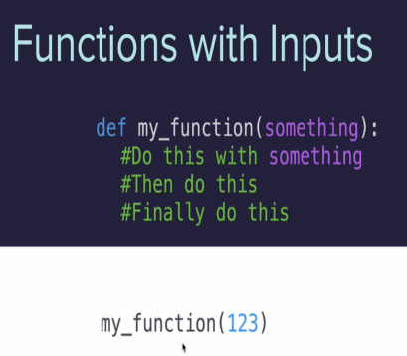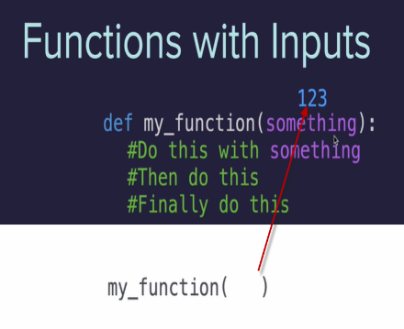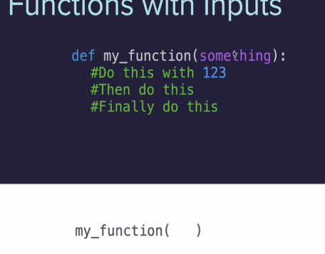

Kind of like plugging a USB into a computer



It is when we call the function that it will pass over the information stored in the variable

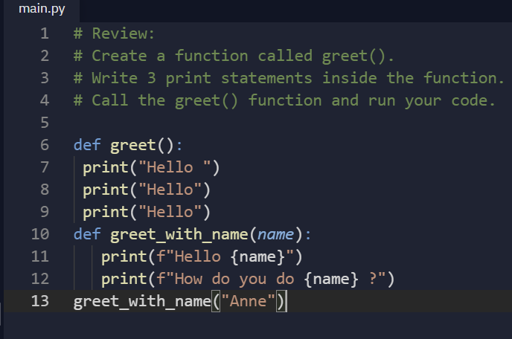

Parameter is the name of the data

Argument is the actual piece of data 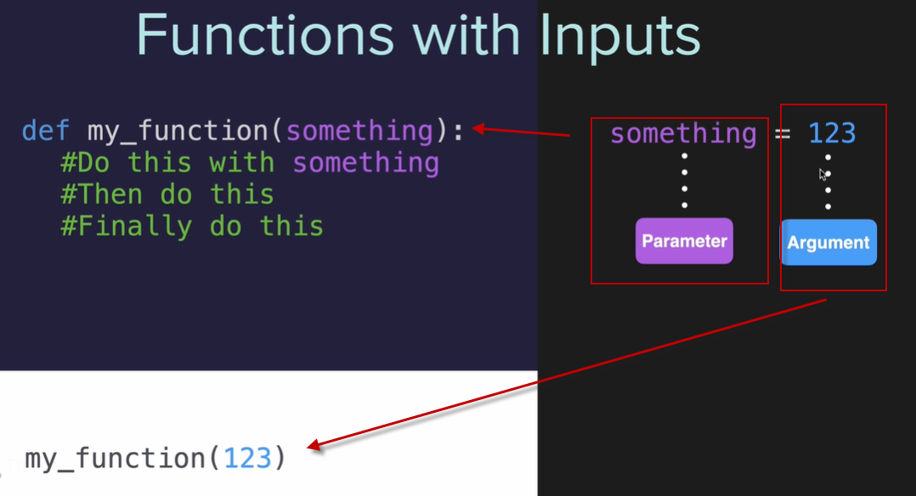

Positional vs Keyword Arguments – positions wit more than one input

The order matters

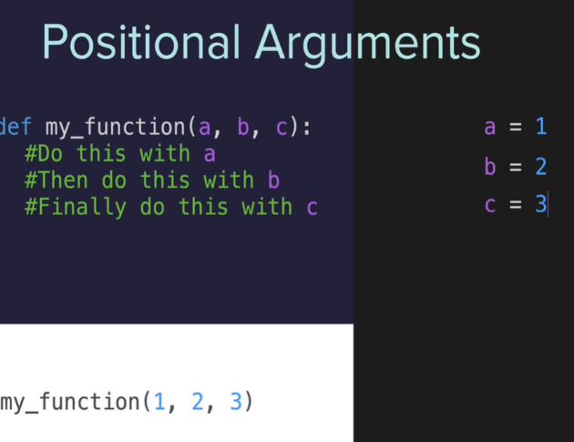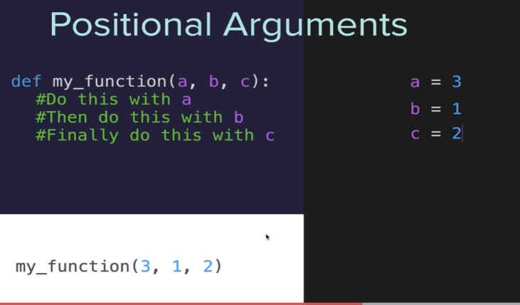

Keyword Arguments set with an = sign when calling 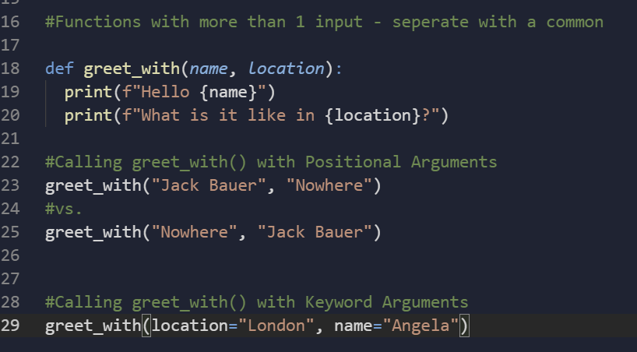, the position doesn’t matter

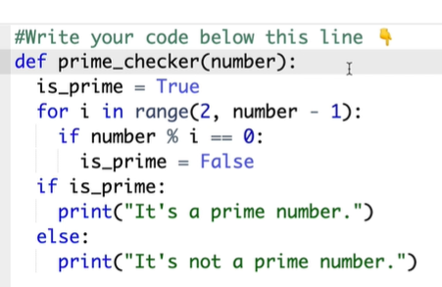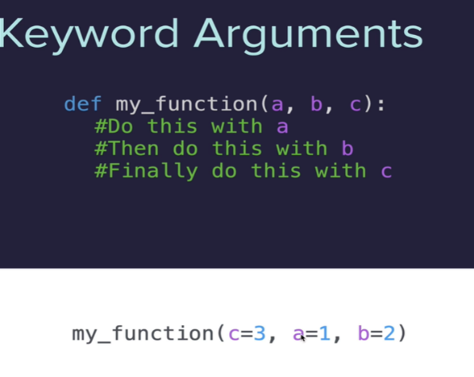

Paint Area Calculator

Round up in python

<https://stackoverflow.com/questions/2356501/how-do-you-round-up-a-number-in-python>

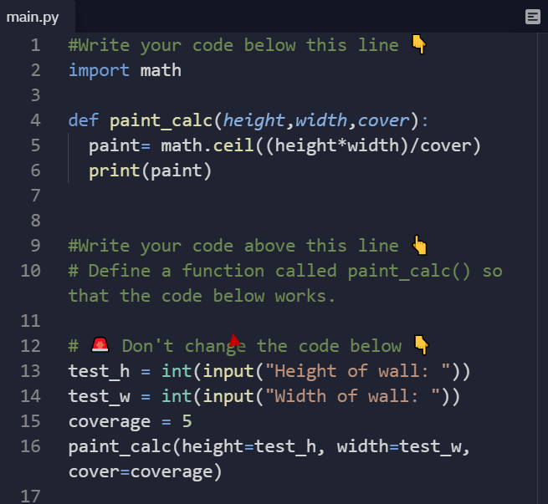

Prime number checker

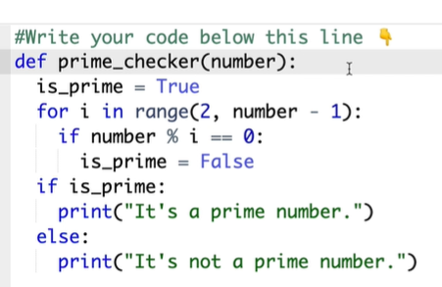

Caesar Cipher Part 1 encryption

<https://www.w3schools.com/python/ref_list_index.asp>

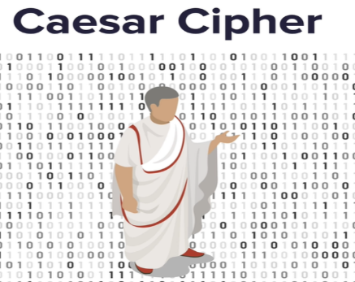

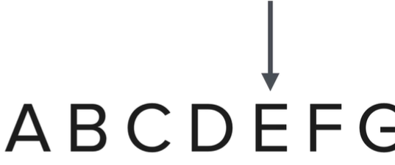

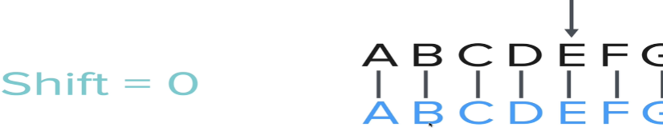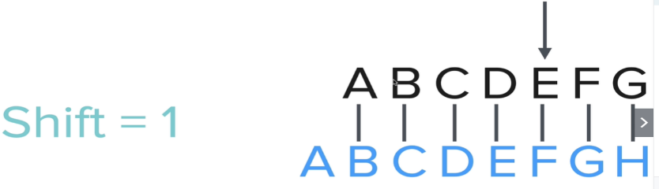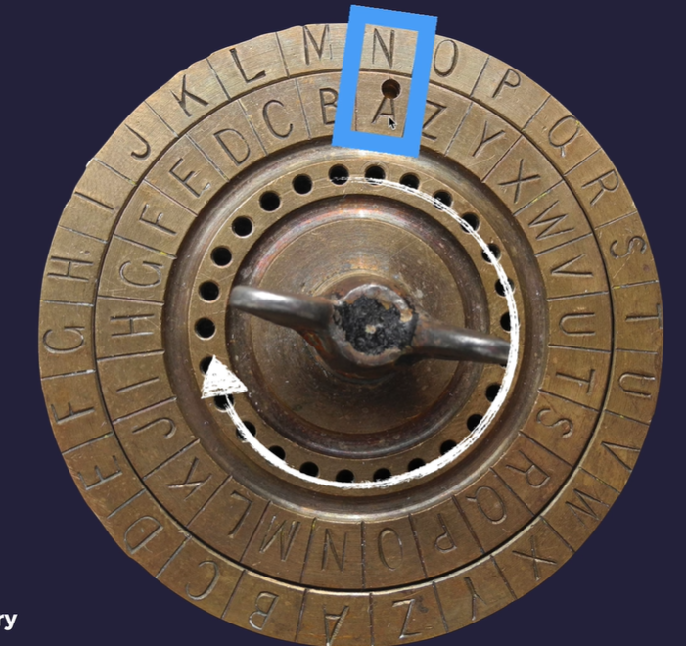

<https://www.geeksforgeeks.org/python-split-string-into-list-of-characters/>

<https://stackoverflow.com/questions/176918/finding-the-index-of-an-item-in-a-list>

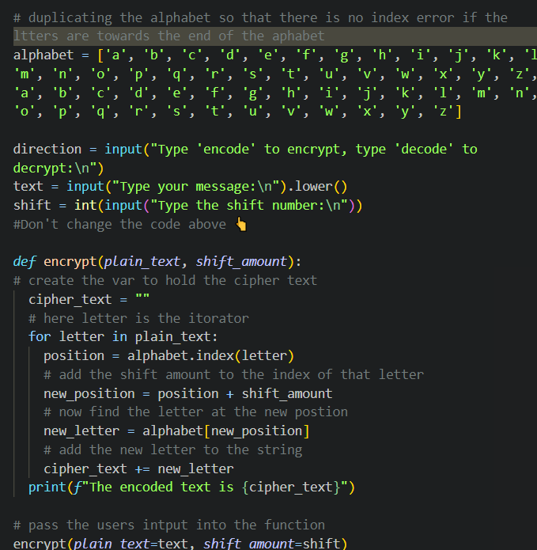

Part 2 – decrypting

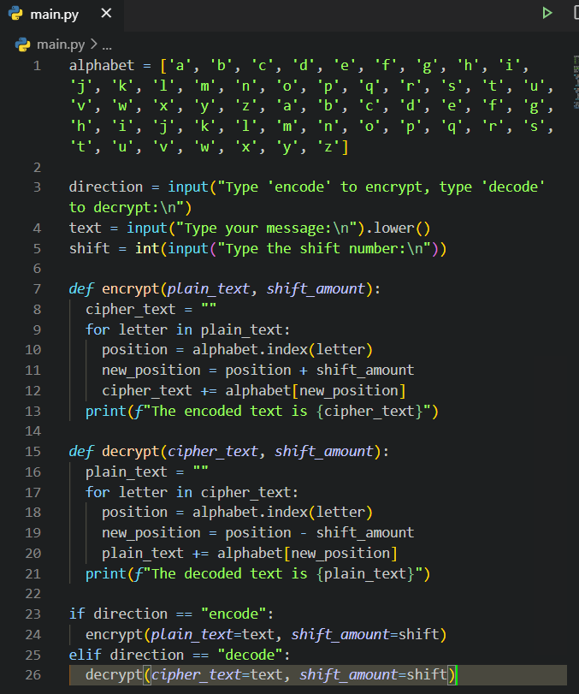

Final code

